| Juiceshop Walkthrough Diploma in CSF  Year 3 Apr 2022 (Semester 5) | 3 Stars |
| --- | --- |
| Practical |
| Upload Size | |

**OBJECTIVES**

* Learning how to exploit the insecure deserialization vulnerability and manipulate the complaint section.
* OWASP vulnerabilities:Insecure Deserialization, Software and Data Integrity(A08:2017, A08:2021)

**Prerequisite**

* Burp Suite

**Challenge – Upload Size**

* Upload a file larger than 100 kB.
* Upload Size - Difficulty: 3/6 stars

**Step 1**

Open Burp Suite and set Intercept to “Off” under Proxy tab. Click “Open browser” and head to your Juice Shop link

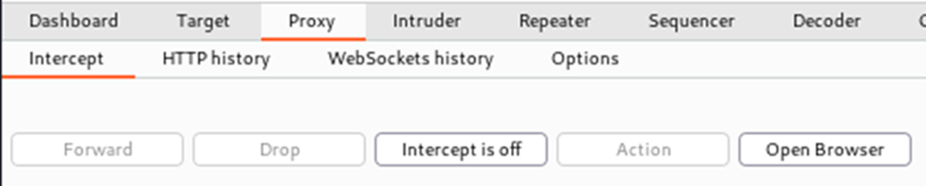

**~ Continue Practical below~**

**Step 2**

Head to the Complaint section of Juice Shop by clicking followed by “Complaint” (ensure that you are logged in to an account)

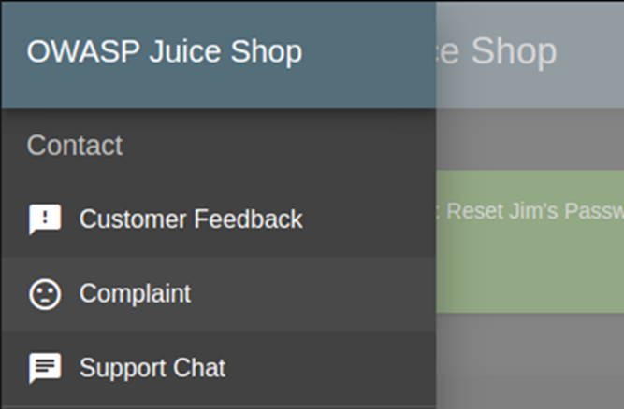

**Step 3**



Type in a random message in the Message box and click

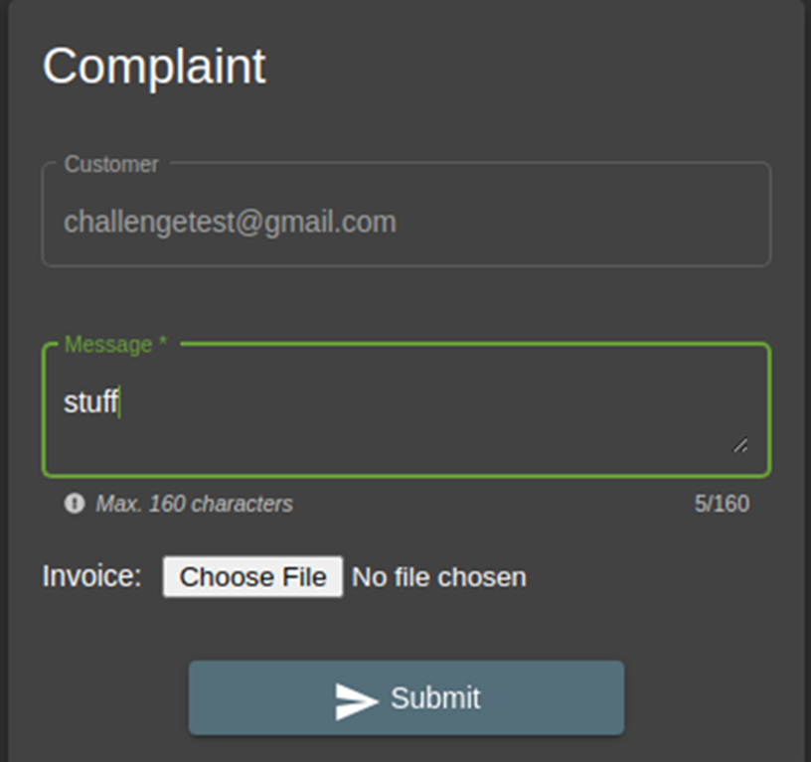

**Step 4**

Upload a pdf file smaller than 100kB and **before clicking Submit, head over to Burp Suite and turn intercept to “On”**

[You can create the pdf file by creating a text file, entering a few words, and saving it as a .pdf extension]

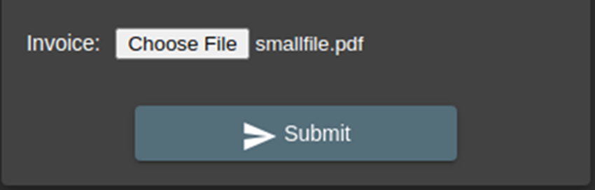

**Step 5**

Switch to Burp Suite and find URL of “/file-upload”



**Step 6**

Right click and “Send to Repeater”

**Step 7**

In repeater, replace the text that was uploaded with text that is bigger than 100 kB.

[You can copy the text and keep pasting the same text several times until you feel like it exceeds 100 kB]

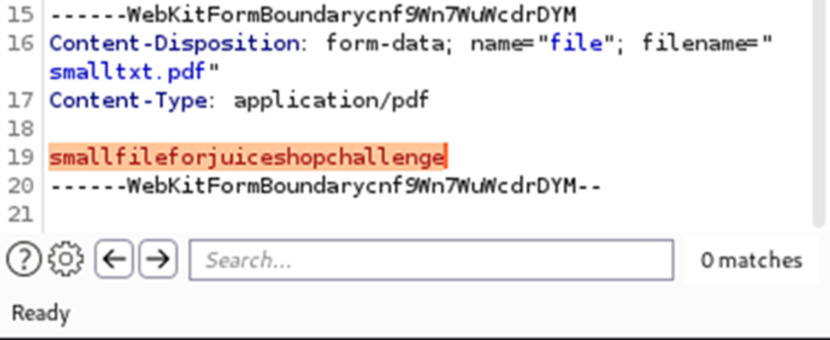

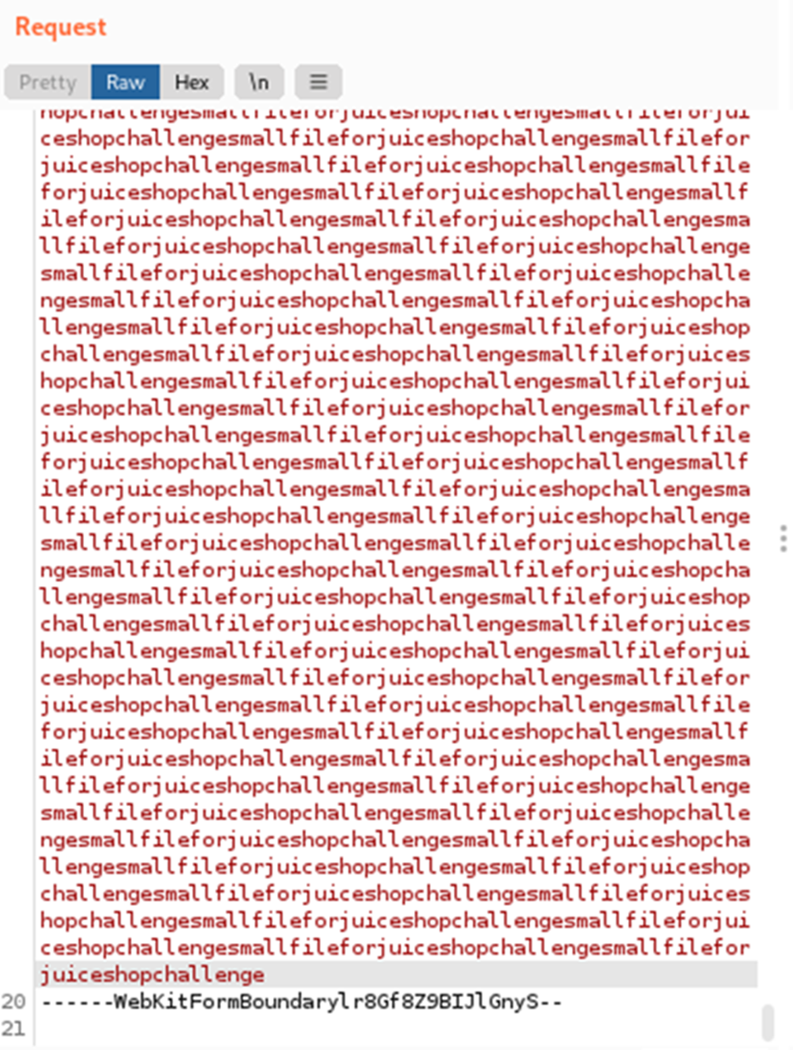



Step 7: Click and the challenge is complete



**~ End of Practical~**